Hierarchical GMS Design
Course: CSS 587A Computer Vision
Authors: Brennan O’Reilly, Pranshu Bhardwaj, Matthew Wong

Overview
The purpose of this document is to capture the conceptual and technical design for implementation of Hierarchical GMS (HGMS). As described in the HGMS project proposal the purpose of HGMS is to explore approaches and implementations for extending the original Grid-based motions statistics (GMS) implementation. Extension of the original GMS implementation addresses current limitations in the number of features and image sizes that can be processed as well as provide greater robustness to image transformations that affect finding true matches.

The GMS approach utilizes the concept of coherence constraints to derive a statistical method to find reliable feature matches. While GMS is fast and reliable it requires use of a fixed 20 x 20 grid of non-overlapping cells for efficiency when scoring feature matches. The use of a fixed 20 x 20 grid was determined empirically by the authors to work with 10,000 features. However, the authors also acknowledged that more grid-cells improve match localization but may impact computational time. The authors also acknowledged that while the GMS process is robust and does offer scale and rotational support, there are limitations in-terms of in-plane rotation, images that violate the smooth lateral motion assumption, and large well textured images with more than 10,000 features.

HGMS proposes introducing a flexible hierarchical refinement process to GMS that increases robustness to scale, transformation, and texture differences. HGMS offers three enhancements as a processing pipeline to the original GMS algorithm:

HGMS Processing pipeline
- Multi-stage feature match filtering (Coarse -> Fine)
- Local affine transformation feature match filtering
- Multi-plane feature match filtering
- Combination stage that returns all inliers from prior 3 stages

The remaining sections of this document further describe the features of HGMS as well as the design and testing methodology.

Problem to Solve
While GMS is robust the paper’s authors acknowledge the following limitations that are addressed through the HGMS processing pipeline and multi-stage approach.

ID | Limitation | Description | Approach
L01 | Smooth lateral assumption | GMS is based on key assumptions related to smooth lateral motion which provides the basis for how GMS grids and then scores feature matches. The assumption works well when an image pair has smooth lateral motion, but in images where the lateral motion is not smooth or consistent then the assumption becomes a limitation. The smooth lateral assumption is acknowledged by the authors that it limits in-plane rotational invariance | Local Affine Transformation and Multi-plane Support
L02 | Fixed feature number 10,000 | Empirically the GMS authors found that 10,000 features was the maximum number permissible for real-time performance. To address large images with greater than 10,000 features the authors resized the images to 480 x 640 before processing through feature matching. | Hierarchical GMS Support
L03 | In-plane rotational invariance | GMS is competitive with ratio-test at extreme rotations however performance is better when rotations are limited. | Local Affine Transformation Support

Table 1. GMS limitations

HGMS addresses the limitations of GMS by offering a processing pipeline with multiple stages where each stage addresses a specific limitation or concern. Each stage can be configured to utilize the output from a prior stage or to operate independently in which case the output from all stages will be aggregated together and returned as a set of inliers.

How the Solution is Anticipated to Work
HGMS offers a multi-staged approach to provide robust feature match filtering. Each stage of the HGMS processing pipeline addresses specific limitations in the GMS algorithm with the goal of preserving as many true matches as possible. Additional stages in the GMS processing pipeline may impact performance however any performance impacts will be balanced with the increase in feature match filtering accuracy and one performance goal of HGMS is to operate at real-time similar to GMS.

Figure 1 captures the four stages that are included in the HGMS processing pipeline. The first and last stages are required and the second and third stages are optional stages that can be enabled or disabled based on parameters specified when executing the HGMS processing pipeline.
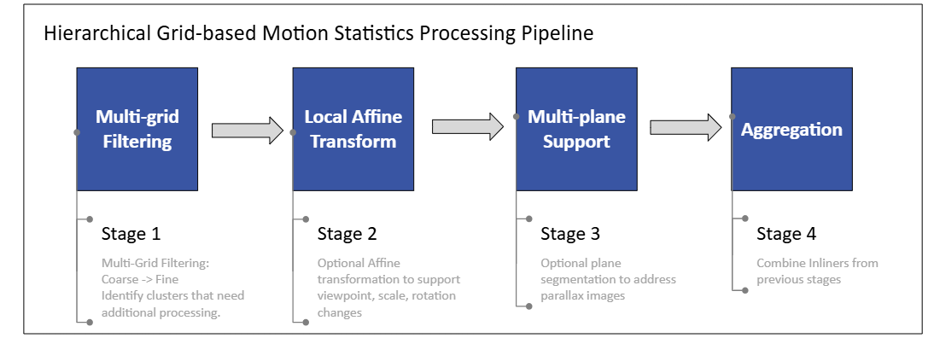
Figure 1. HGMS processing pipeline

Each stage takes a slightly different approach to determining inliers and each approach is related back to the limitations identified in the GMS paper.

Stage 1 - Multi-grid filtering
Stage 1 provides the course level filtering for rejecting obvious outliers. In the GMS paper the grid utilized for this stage is a 20 x 20 fixed grid of non-overlapping cells. This stage will operate like GMS however it will provide filtering through multiple grid stages starting with a coarse grid and ending with a fine grid. Each refinement step will help address image regions with varying keypoint density as well as viewpoint changes.

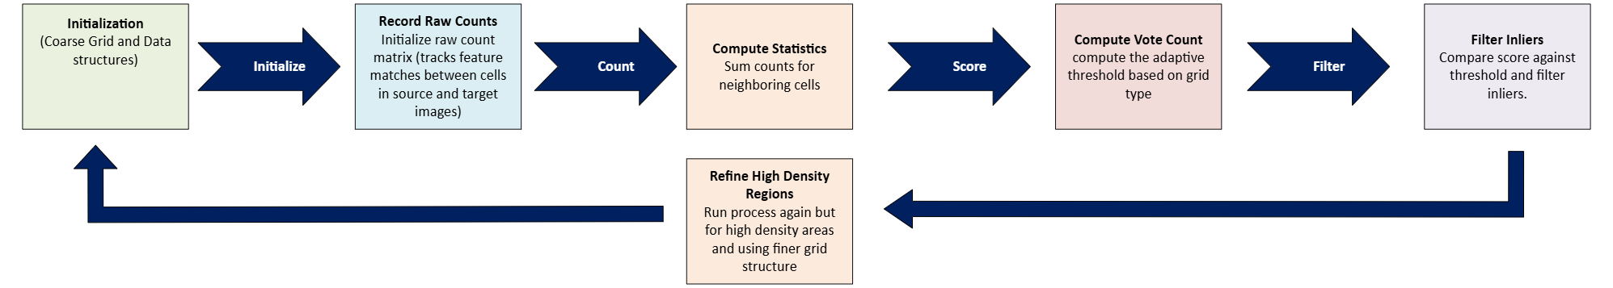
Figure 2. Hierarchical Multi-grid GMS Filtering

Algorithm Processing Steps
Input: One pair of images
Initialization:
- Perform feature detection on images and calculate keypoints and descriptors
Execution:
- For each grid in grid_hiearchy (coarse, mid, fine):
  - Divide image1 and image2 into grid_hierarchy cells
  - Locate each match and assign cell1 for keypoints1 and cell2 for keypoints2
  - For each cell pair, compute the statistics:
    - For each neighboring cell pair:
      - Count number of matches that are consistent
    - Compute total vote count
    - Compute adaptive threshold for grid_hierarchy level and cell pair
    - If count < threshold then mark cell pair match as outlier
  - Identify high-density regions needing further refinement and continue with the next level down in grid_hierarchy and regions needing refinement
- Return inliers
Output: Inliers

Stage 2 - Local Affine Transform
Stage 2 provides support for image distortions that can be the result of viewpoint, rotation, and scale changes. This stage will provide support for situations where a textured object is viewed from different angles between images and addresses the assumption that close together features are translated in a corresponding manner. Stage 2 is intended to be run after stage 1 HGMS stage has been completed. Stage 2 will be grouping neighboring matches and then using an affine transform predict how the local keypoints in the first image are translated into the second image. The prediction error will be compared against the threshold and if below the threshold it will be marked as an inlier.

Stage 2 will perform similar steps to GMS in that a 20 x 20 grid will be used for determining regions of match counts. Instead of scoring based on corresponding feature matches, RANSAC will be used selectively to create an affine transformation matrix for cell neighborhoods with large clusters of features. The resulting affine transformation matrix will then be used to predict how a feature may have transformed between images. Feature matches will then be scored and compared against a final threshold. Scores greater than the threshold will be returned as inliers.
Figure 3. Local Affine Transform Process

Algorithm Processing Steps
Input: One pair of images
Initialization:
- Perform feature detection on images and calculate keypoints and descriptors
Execution:
- Divide image1 and image2 into grid_hierarchy cells
- For each grid_hierarchy cell, collect the matches
- If the matches are greater than the RANSAC threshold then:
  - Calculate local affine transform for that cell
  - Using the calculated local affine transform, warp the keypoints in the cell to predict position in image2
  - For each match, compute the error:
      - If error < threshold, then match is considered inlier
      - For each neighboring cell pair:
        - Count number of matches that are consistent
      - Compute total vote count
      - Compute adaptive threshold for grid_hierarchy level and cell pair
      - If count < threshold then mark cell pair match as outlier
  - Return inliers
Output: Inliers

Stage 3 - Multi-plane Support
Stage 3 provides support for parallax images or image scenes with background and foreground objects at different depths. Stage 3 clusters feature matches into layers (planes) and then runs a GMS like algorithm for each plane independently. The resulting inliers are then merged into a single set of inliers.

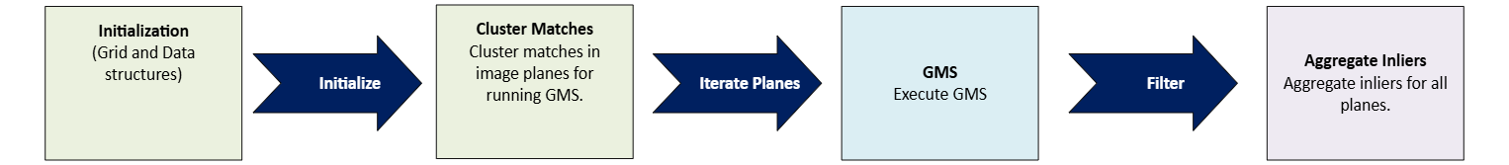
Figure 4. Multi-plane GMS Processing

Algorithm Processing Steps
Input: One pair of images
Initialization:
- Perform feature detection on images and calculate keypoints and descriptors
Execution:
- For each match, computer the motion vectors
- Cluster vectors into prospect planes (clustering parameter to try different algorithms like dbscan, k-means, etc)
- If only 1 plane then return (this stage will be run after HGMS which has already generated inliers)
- For each plane:
  - Collect matches per plane, run GMS
  - Aggregate inliers
- Return inliers
Output: Inliers

Stage 4 - Aggregation
Stage 4 combines output from the prior stages and returns a collection of inlier matches. This stage deduplicates the list of inliers to unique sets of matches. In terms of implementation, the final aggregation stage most likely will not be a separate class and instead part of the processing pipeline.
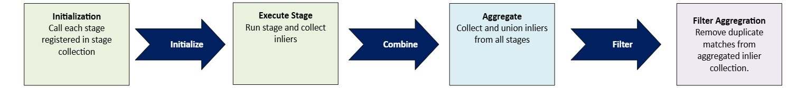
Figure 5. Aggregation and Deduplication Stage

Algorithm Processing Steps
Input: Inliers from previous execution stages
Initialization:
- Validate inliers have been returned from prior execution stages
Execution:
- Union results from prior execution stages
- Remove duplicate matches
- Return inliers
Output: Inliers from prior stages returned without duplicates

Classes to be Implemented
ID | Class Name | Type | Description
C01 | HGMSPipeline | Class | Orchestrator class that provides a matchRun method to execute the processing pipeline as well as the ability to add processing stages.
C02 | ProcessingStage | Abstract class | Abstract class to build HGMS pipeline processing stages. Each stage will adhere to the interface in this class.
C03 | HGMSStage | Class | Class that provides hierarchical filtering using adaptive grid from coarse to fine.
C04 | LATStage | Class | Class that provides local affine transformation support.
C05 | MPStage | Class | Class that provides multi-plane GMS filtering support.

Table 2 provides a list of classes that will be implemented for HGMS.

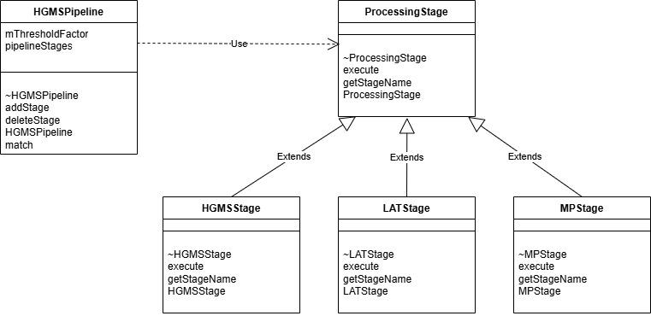
Figure 6. HGMS Proposed Class Diagram

Data Structures
The following section of this document describes the proposed data structures that will be needed to implement the multiple stages for the HGMS processing pipeline. Additional data structures will most likely be utilized during the implementations and therefore the proposed list below may change.

Processing Stage Structures (Used in all stages)
The ProcessingStage abstract class will be a class used to model a pipeline processing stage and serve as an interface for the concrete stage classes (HGMS, LAT, MP). The Processing Stage data structures are essentially common data structures that are used by their respective derived stage classes.
Structure | Type | Description
initialMatches | std::vector<cv::DMatch> | Matches produced by an external matcher such as BFMatcher
matchPairs | std::vector<std::pair<int, int>> | Pair of keypoint indices (queryIdx, trainIdx). Same as GMS mvMatchPairs.
inlierMask | std::vector<bool> | Boolean mask marking matches validated by a stage
inlierMatches | std::vector<cv::DMatch> | Accumulated output of each stage

Table 3. Match Data Structures

Pipeline Structures used in (CO1 - HGMSPipeline)
The HGMSPipeline class will be the processing pipeline orchestration class and the data structures will be used to process output from stages, configuration parameters, and return inliers to the calling application.
Structure | Type | Description
stages | std::vector<std::shared_ptr<ProcessingStage>> | Ordered list of stages. Defined by class diagram.
stageOutputs | std::vector<std::vector<cv::DMatch>> | Inliers produced by each stage (before deduplication)
finalInliers | std::vector<cv::DMatch> | Merged and deduplicated output across all stages
params | struct HGMSParams (custom) | Possible tunable options: [enableAffine, enableMultiplane, thresholds, grid sizes]

Table 4. HGMSPipeline Data Structures

Grid-level Structures used in (CO3 - HGMSStage)
The HGMSStag represents the hierarchical stage class and the data structures that will be used to generate inliers using a hierarchical processing approach.
Structure | Type | Description
normalizedPts1, normalizedPts2 | std::vector<cv::Point2f> | Keypoints normalized to 0,1 range for grid indexing. Same representation as original GMS.
gridSize | cv::Size | Number of cells in X and Y (e.g., 8x8, 16x16, 20x20, etc)
numCells | int | Total grid cells (gridSize.width x gridSize.height)
motionStats | cv::Mat (type CV_32SC1) | 2D array where motionStats[left_cell][right_cell] counts matches. Same structure as mMotionStatistics in GMS.
neighborsLeft, neighborsRight | cv::Mat (type CV_32SC1, rows = numCells, cols = 9) | 3x3 neighbor table. Same as GMS mGridNeighborLeft and mGridNeighborRight
cellPointCountLeft | std::vector<int> | Number of matches assigned to each left cell
cellPairs | std::vector<int> | For each left cell: the best matching right cell or -1 if inconsistent

Table 5. Abstract HGMSStage Class Data Structures

Affline Transform Structures used in (CO4 - LATStage)
The LATStage represents the hierarchical stage class and the data structures that will be used to generate inliers using a local affine transformation processing approach
Structure | Type | Description
localClusters | std::vector<std::vector<int>> | For each cell, indices of matches belonging to local region
afflineMatrix | cv::Mat (2x3 float) | Estimated affine transform between local neighborhoods. Computed using OpenCV’s estimateAffinePartial2D
predictedPoints | std::vector<cv::Point2f> | Keypoints from image 1 warped into image 2 coordinate system
residualErrors | std::vector<float> | Per-match Euclidean error between predicted and actual positions

Table 6. LATStage Data Structures

Plane Clustering Structures used in (CO5 - MPStage)
The MPStage represents the multi-plane stage class and the data structures that will be used to generate inliers using a multi-plane processing approach
Structure | Type | Description
motionVectors | std::vector<cv::Point2f> | dx, dy displacement for each match.
planeLabels | std::vector<int> | Cluster ID for each match (e.g., result of DBSCAN or k-means).
matchesPerPlane | std::vector<std::vector<int>> | Index lists of matches belonging to each plane.
planeInliers | std::vector<std::vector<cv::DMatch>> | GMS-filtered inliers computed independently per plane.

Table 7. MPStage Data Structures

Test Data and Methodology
This section of the document addresses the test data and methodology that will be used to determine performance of HGMS relative to GMS.

Test Data

(All the image pairs we use must also be run through regular GMS for comparison with HGMS to show the improvements in our evolution of GMS)
- Regular Image pairs with smooth lateral displacement for the objects
- Image pairs with significant change in object scale
- Image pairs with heavy object rotations
- Image pairs with both heavy scale change and rotation

Datasets
The GMS paper utilized four datasets for testing, TUM, Stretcha, VGG, and Cabinet. For testing of HGMS our goal is to use at least one of the four datasets for comparison purposes. If time permits then multiple datasets will be used for testing and comparison purposes. The dataset that will be used will contain images where GMS has expressed limitations.

Methodology
All image pairs will be run through both GMS and HGMS and will be compared side by side.
A comparative analysis of the performance and results must be performed. Performance metrics will be gathered for each execution and compared. The selected metrics will allow for direct comparison between HGMS and GMS and have been captured in the performance metric section of this document.

In addition to testing image feature matching performance a stretch goal for our team is to also test performance of feature matching with real-time video.

Performance Metrics
The specific metrics that will be used to compare performance between HGMS and GMS include:
- Precision, Recall, and F-Measure between HGMS and GMS on the selected dataset
- Magnitude of correct matches (surface level only because we can't count each correct match)
- Hardware performance: How smoothly and efficiently both algorithms run on the same hardware
- Time taken to perform the same magnitude of matches
- Density of Match Clusters (expected to be higher for HGMS)

Initial Results
The initial results presented below are screenshots of feature matches drawn by the GMS algorithm and not HGMS. We anticipate that given the same image pairs that HGMS will perform as well if not better than the GMS algorithm.
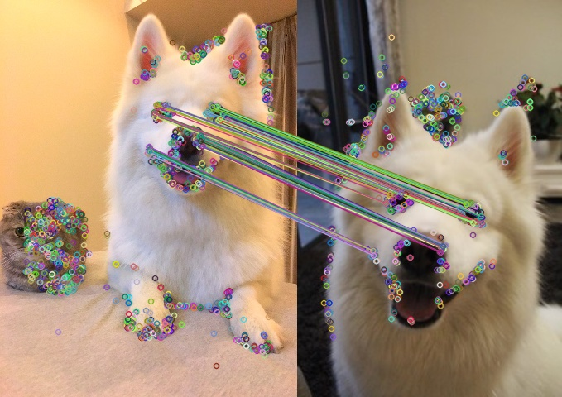
Figure 7. Dog images matched by GMS


Figure 8. Cat images matched by GMS

References
[1] J. Bian, W.-Y. Lin, Y. Matsushita, S.-K. Yeung, T.-D. Nguyen, and M.-M. Cheng, “GMS: Grid-
based Motion Statistics for Fast, Ultra-Robust Feature Correspondence,” Proc. IEEE Conference on Computer Vision and Pattern Recognition (CVPR), 2017. https://openaccess.thecvf.com/content_cvpr_2017/papers/Bian_GMS_Grid-based_Motion_CVPR_2017_paper.pdf

[2] Y. Han, Z. Long, Y. Zhang, J. Wu, Z. Fang, and R. Fan, “Generalized Correspondence Matching via Flexible Hierarchical Refinement and Patch Descriptor Distillation,” Proc. IEEE International Conference on Robotics and Automation (ICRA), Yokohama, Japan, 2024. https://ieeexplore.ieee.org/stamp/stamp.jsp?tp=&arnumber=10611456

